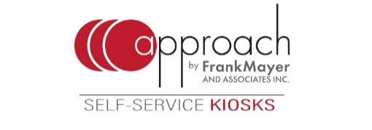
FRANK MAYER AND ASSOCIATES, INC. TO DEMONSTRATE
APPROACH SELF-SERVICE KIOSKS AT ICX SUMMIT
See Frank Mayer and Associates, Inc.’s expanded line of self-ordering kiosks at the
2019 Interactive Customer Experience Summit in Dallas June 4-6.

GRAFTON, WI – Find Frank Mayer and Associates, Inc.’s self-service kiosk line Approach at the 2019 Interactive Customer Experience (ICX) Summit at Omni Frisco Hotel in Dallas June 4-6. The freestanding, floor tablet, and counter self-order kiosks will be on display in booth #12, where attendees can test the units and interact with the kiosks’ QiTM software by ADUSA.
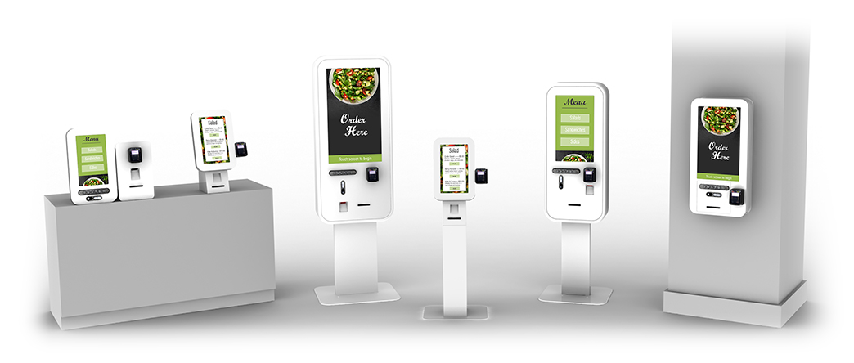
In addition to the original freestanding Approach floor unit, available as both a 32- and 22-inch touchscreen, Frank Mayer and Associates, Inc. recently expanded its roster of self-service kiosks to include a countertop unit, tablet, and wall unit.
The new line marries smart design with different sizes, offering an array of customization options and brand personalization – all while being backed by Frank Mayer and Associates, Inc.’s trusted name in delivering experience and unsurpassed quality in the interactive kiosk market.
Frank Mayer and Associates, Inc. is a leader in the development of in-store merchandising displays, interactive kiosks, and store fixtures for brands and retailers nationwide. The company helps retailers and brands utilize the latest display solutions and technologies to create engaging customer experiences. For more information on the Approach family of kiosks, visit www.frankmayer.com/approach
***
CONTACT:
David Anzia, Senior Vice President of Sales
Frank Mayer and Associates, Inc.
1975 Wisconsin Ave., Grafton, WI 53024
(855) 294-2875 | info@frankmayer.com

