BUBBA CAPTURES SPORT FISHING LIFESTYLE WITH LATEST MERCHANDISING DISPLAY
Manufacturer of angling equipment, BUBBA debuts new merchandising display
to showcase company’s sport fishing products.
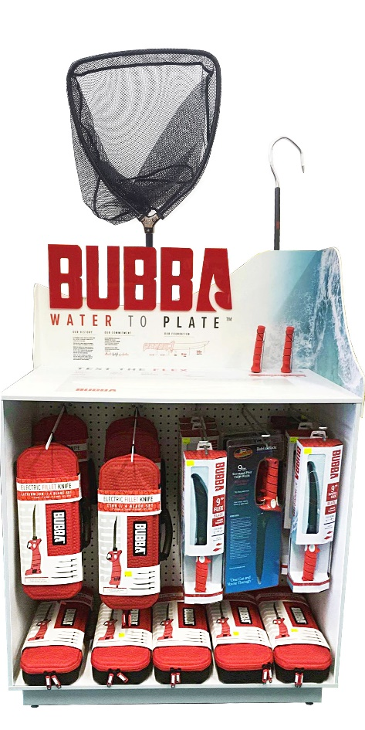
GRAFTON, WI – Frank Mayer and Associates, Inc. has partnered with BUBBA, a leading manufacturer of fillet knives and fishing tools, to design, engineer and produce an in-store display solution to showcase the brand’s assortment of sport fishing merchandise, including fishing nets, gaffs, pliers, fillet knives, electric fillet knives, gloves, and much more.
When developing the display concept, BUBBA required a design that would fit a small footprint while merchandising as much product as possible, a look that endorsed the sport fishing lifestyle, and imagery that could be easily updated in the field.
The company also required an interactive component to allow consumers to use the product and understand the ergonomics associated with the BUBBA knife’s iconic handle and blade.
A fish-shaped cutting board and simple measuring tape were added elements to help customers connect to a time and place they would use the brand’s tools, and custom peg hooks and slat wall designs not only allow for heavier electric knives without sagging but offer unique product configurations based on each dealer’s needs.
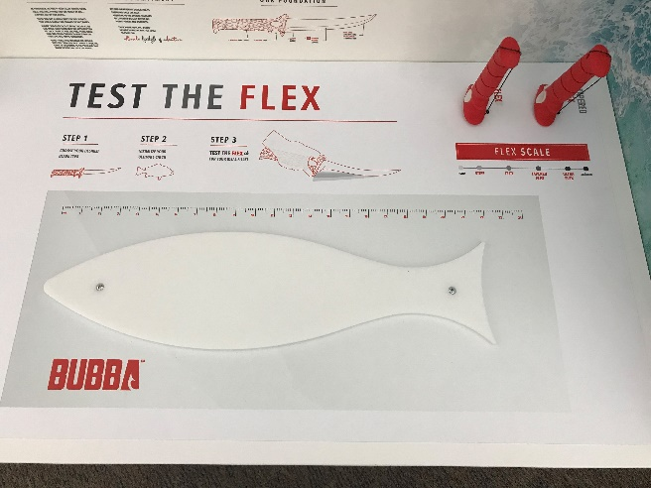
The final design was shipped to 500 dealer locations nationwide. Half the sets showcase salt water graphics and the other half illustrate fresh water images to personalize display programs to each dealer’s region.
Image of full BUBBA display
Frank Mayer and Associates, Inc. is a leader in the development of in-store merchandising displays, interactive kiosks, and store fixtures for brands and retailers nationwide. The company helps retailers and brands utilize the latest display solutions and technologies to create engaging customer experiences. Visit www.frankmayer.com for more information.
Image of top of BUBBA display
***
CONTACT:
Dave Loyda, Marketing Manager
Frank Mayer and Associates, Inc.
1975 Wisconsin Ave., Grafton, WI 53024
(262) 377-4700 | info@frankmayer.com

