2021 Census Nomis Navigation Instructions

Nomis is a service run by Durham University on behalf of the Office for National Statistics.

To explore 2021 census data

If you are looking for 2021 Census datasets to explore different areas, or broader topics, then from the homepage www.nomisweb.co.uk

- Click on Query data, this can be found in the upper right quartile on the Nomis homepage.

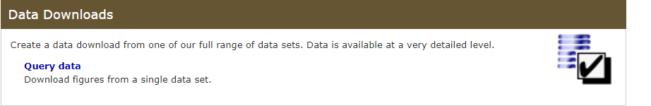

Scroll down to Census 2021 and click on Topic summaries (for single variables only) that have been published.
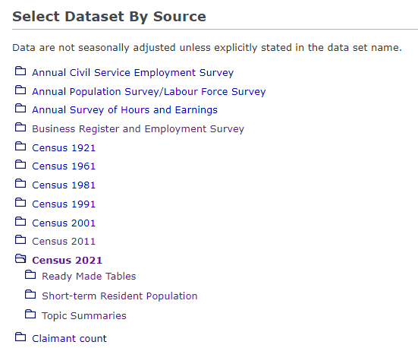

- Select dataset required and click on title.

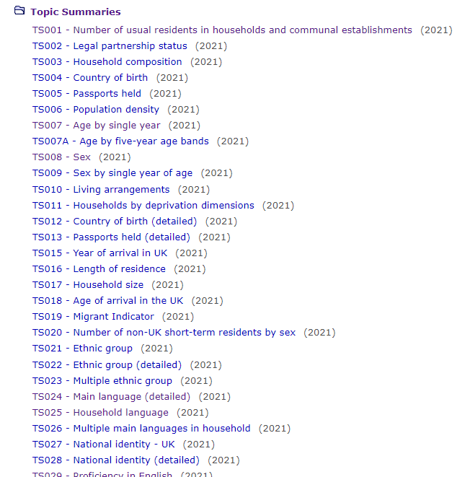

Once you have selected your dataset, TS008 – Sex for example, this screen should appear

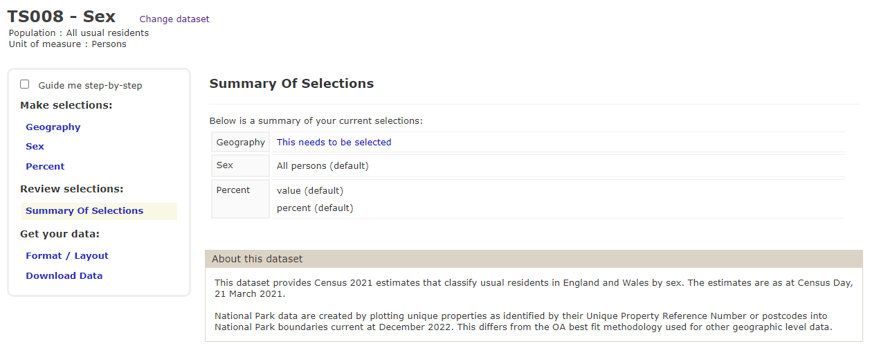

Make sure that a tick is in the Guide me step-by-step box to the left which will provide you with instructions and a walkthrough on how to download the data.

- Begin your geography selection on the left-hand side within the ‘Make selection’ pane by selecting ‘Geography’

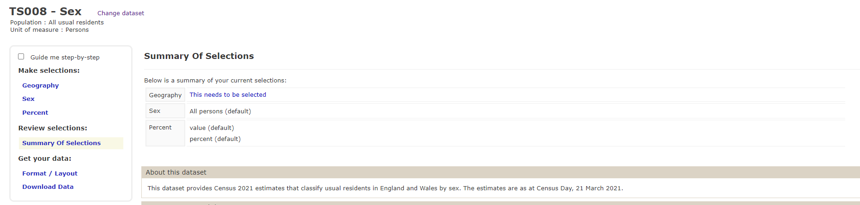

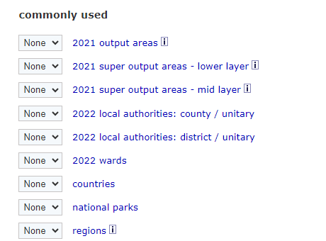

Select a geography level by either clicking on the word e.g., countries,

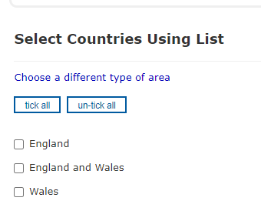

or by using the drop-down menu e.g., countries

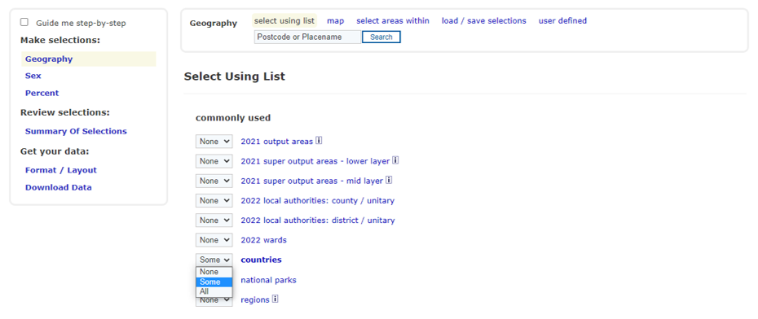

You can add more than one type of geography if required.

- Once you have made your selection

Choose your variables within the left-hand side pane, you will need to do this for each variable selected.

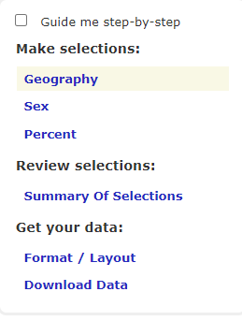

Select all details required by clicking in the boxes.
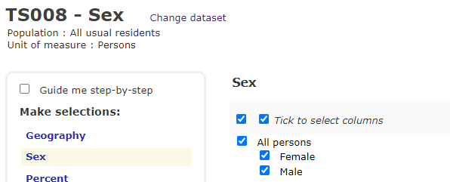

- When you have completed each variable, you can select what format you’d like the data downloaded in.

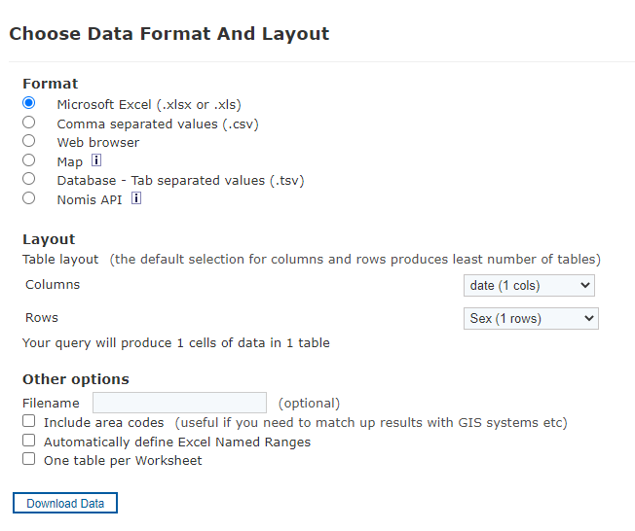

Once you have selected your format, click Download Data to download your data.

You can also use the “areas within” facility to help you with your specific query.

Follow steps a to c from above:

Once you have selected your dataset, TS008 for example,

Click on ‘Geography’ on the left-hand side and this page will appear

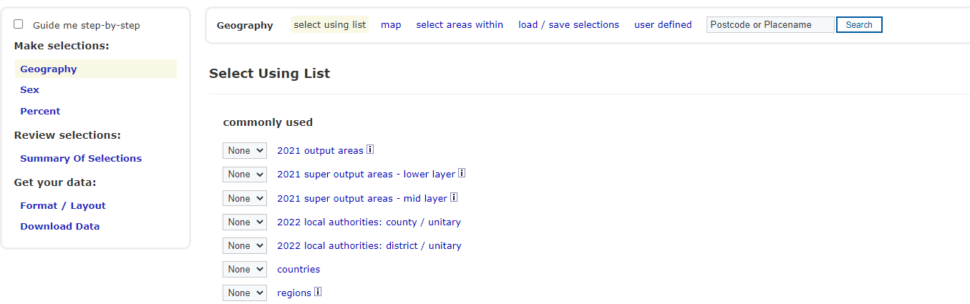

Click on Select areas within the middle of the page
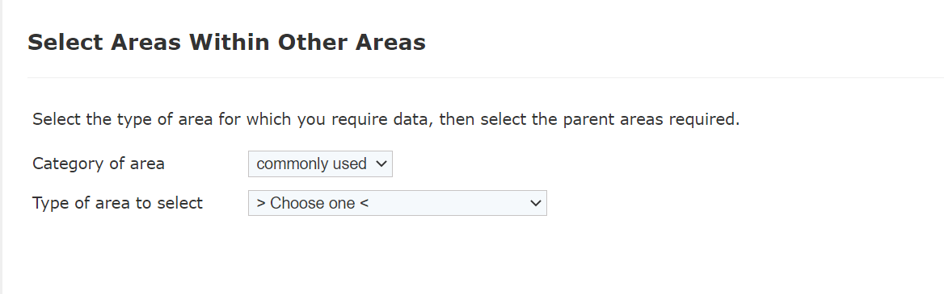

From the drop-down menu choose an area e.g., 2021 output areas

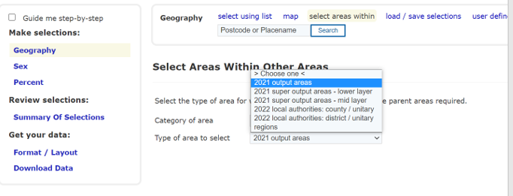

Once an area has been selected this screen will appear –

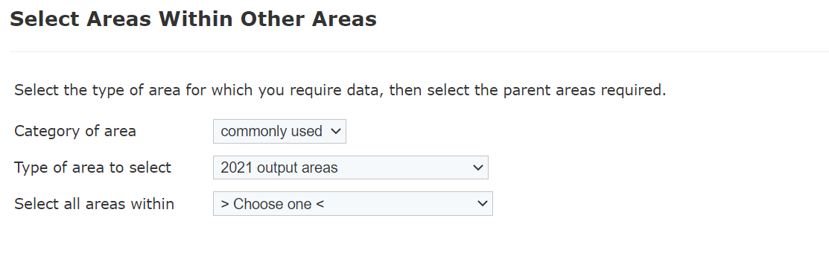
select your area of choice from the drop-down menu again,
e.g., 2022 local authorities: districts

Your screen should look like this:
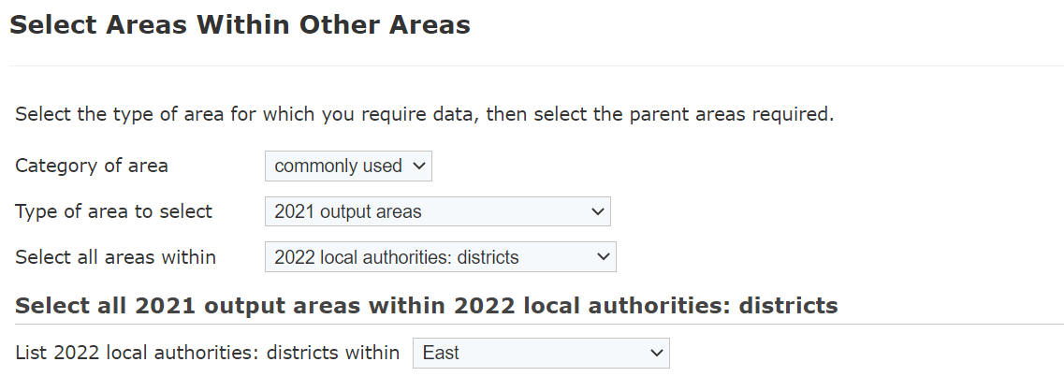

Using the drop-down menu, change the selection to your area of choice.

e.g., for Exeter – change the List of 2022 local authorities: districts within from East to South West

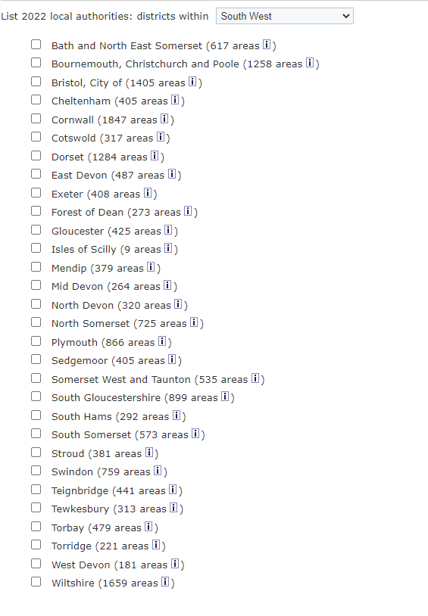
Select Exeter and then follow instructions from section e mentioned above.

Bulk downloads are available

Please follow process a to c from above and instead of selecting countries choose 2021 Output areas.

Unfortunately, because the size of the data involved you will need to do each area individually rather than all so will need to select “some” from the drop-down menu.

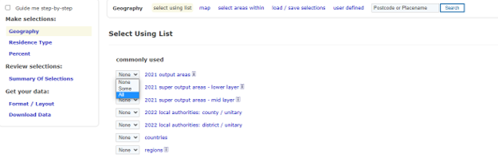
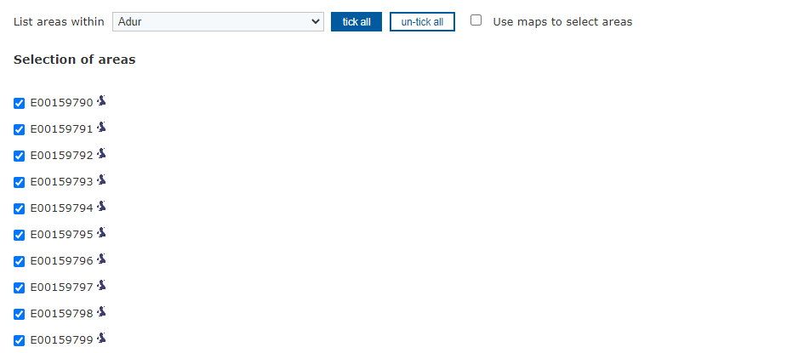

Follow the same steps until the end of the query process.

As an example, Change Adur to Allerdale and so on.

Alternatively, from the Nomis homepage:

Click on 2021 Data catalogue

Go to Bulk Data Downloads grey tile:
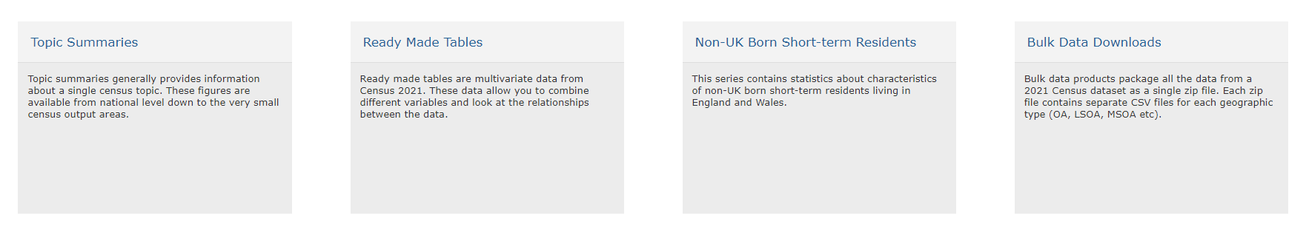

Choose a table, then click on the link on left hand side

Open file, and then click on area of your choice from the list below that appears
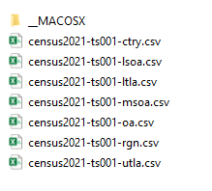

For Ready-Made Tables you will need to scroll down to the Ready Made tables section instead of the Topic Summaries section as described in step a) From here, follow the same instructions for choosing geography and variables as before.

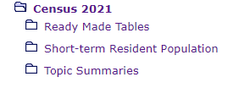

Another way to access Census 2021 data from https://www.nomisweb.co.uk/ is by using the Data Catalogue.

- From the above link click on 2021 Data catalogue title under the purple section – ‘Census Statistics’. This will take you to the following page:
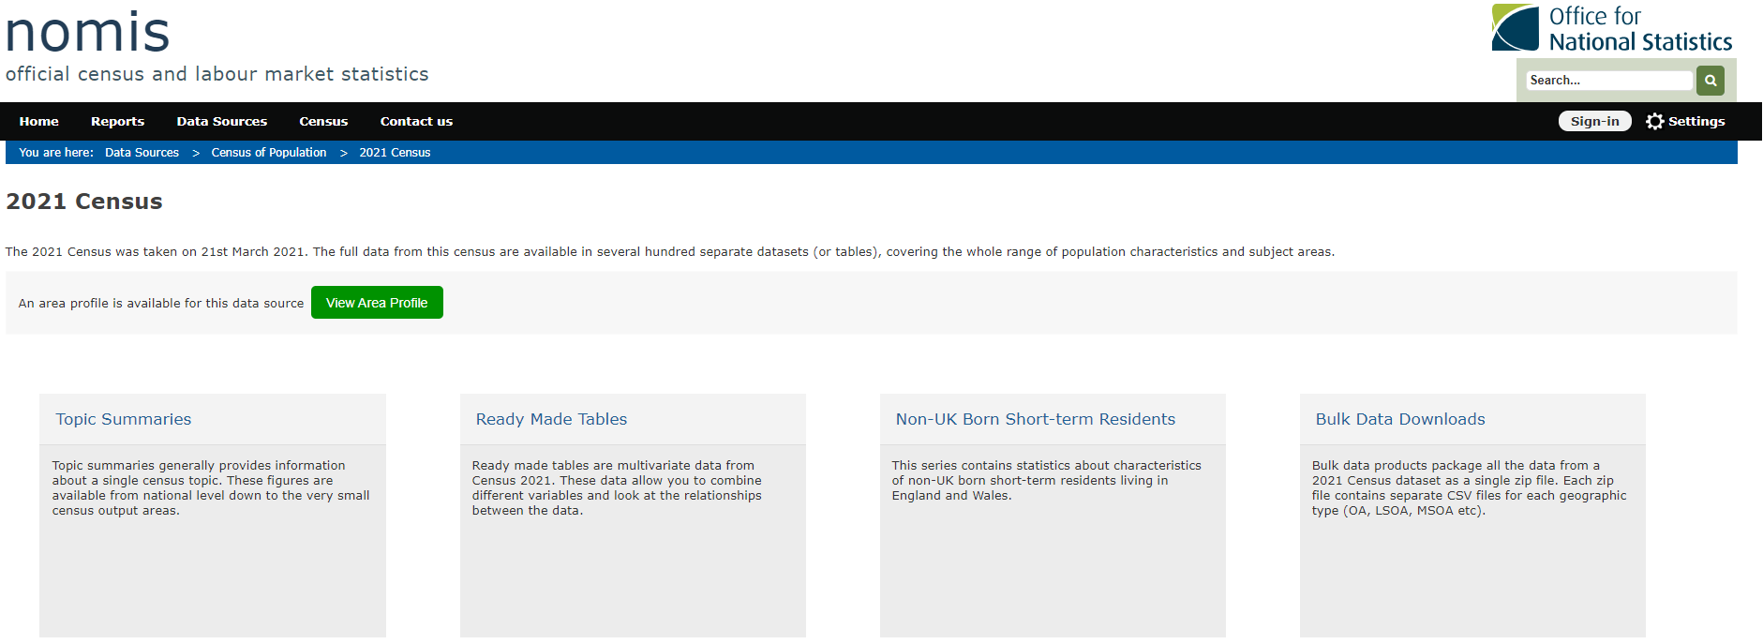
From here you can either select one of four tiles: Topic summaries, Ready Made Tables. Non-UK Short-term Residents or Bulk Data Downloads.

By clicking on the Topic Summaries tile, a list of all the topic summaries datasets (for single variables only) that have been published will be available.
https://www.nomisweb.co.uk/sources/census_2021_ts

By clicking on the Ready-Made Tables, a list of all the ready-made datasets will appear:
https://www.nomisweb.co.uk/sources/census_2021_rm

By clicking on Non-UK Short-term Residents, a list of all these datasets will appear:
https://www.nomisweb.co.uk/sources/census_2021_st

If you’re looking at one particular area, the Local Area Report is the easiest way to find key statistics for one area.

From the Nomis homepage www.nomisweb.co.uk , click on 2021 data catalogue section and you will be presented with this page:

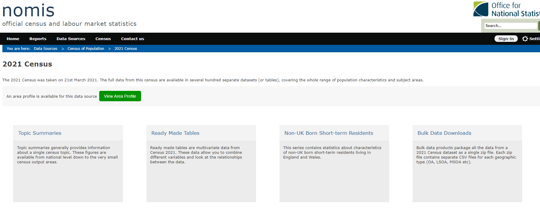

Click on the green tile labelled ‘View Area Profile’ and proceed to enter the name of the area you’re looking for. e.g., Fareham

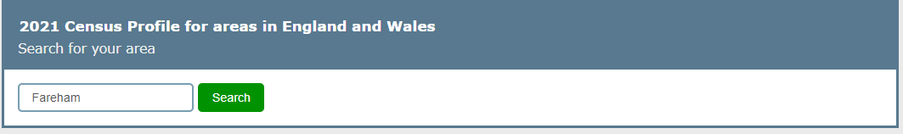

Next, select Search and you’ll be able to choose from a list of areas that match what you’ve entered

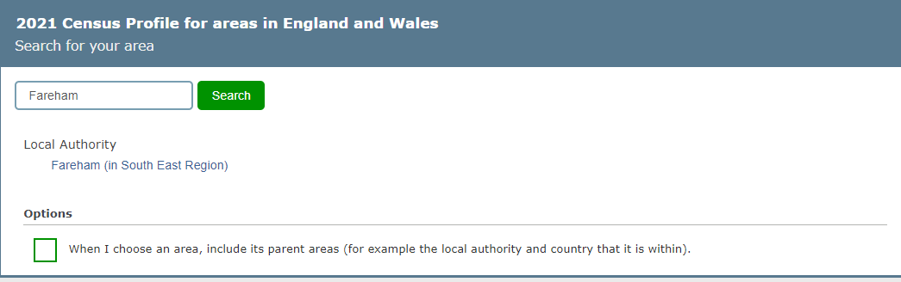

Click on the name of your preferred area.

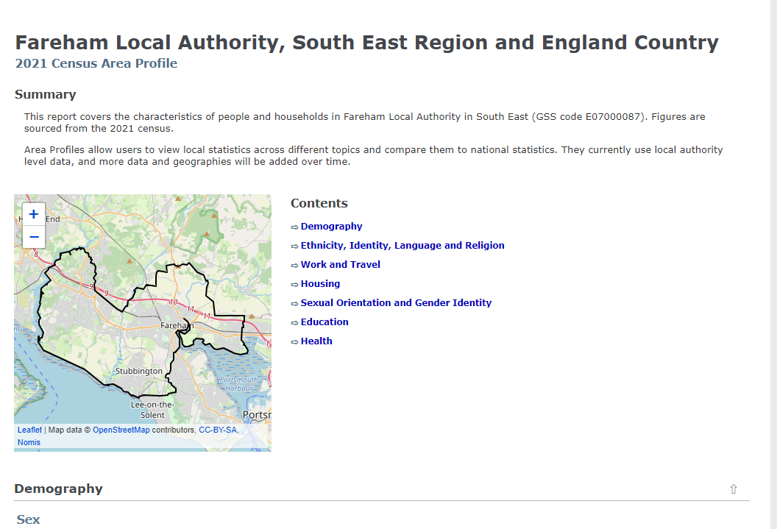

The local area report gives a brief overview, as well as a selection of univariate datasets and links to the tables mentioned so that you can explore further.

Unfortunately, this is currently only available at Local Authority District geography level and above.

